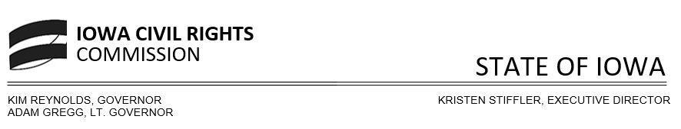
Monday, August 12, 2024
3:30-4:00 p.m.
https://us06web.zoom.us/j/86441929824?pwd=PuEdwhwyuBeLxhATpzALwKLPn0W3IS.1

AGENDA

- Roll Call Commissioners

- Commissioners’ role
  - What is our mission/focus
  - How to approach work

- Agenda focus for Friday’s work session
  - Reminder Kristen will not be present and this month’s meeting will be a working session that will focus on the mission discussed today, meetings moving forward

- Next Meeting
  - Friday, Aug 16, 2024

- Adjournment

Any person needing special assistance or with accessibility needs should contact Kaitlin Smith at 515-281-4121 or icrc@iowa.gov

******************************************************************************************
Attending the Iowa Civil Rights Commission virtually – please see the below information

The ICRC continues to provide additional options for those wishing to attend virtually. The ICRC meeting will be set up as a Zoom Webinar and will be recorded.

https://us06web.zoom.us/j/86441929824?pwd=PuEdwhwyuBeLxhATpzALwKLPn0W3IS.1
Passcode: 8uRB9t
Or One tap mobile :
+13017158592,,86441929824#,,,,*944983# US (Washington DC)
+13052241968,,86441929824#,,,,*944983# US
+1 305 224 1968 US
+1 309 205 3325 US
+1 719 359 4580 US
+1 253 205 0468 US

Webinar ID: 864 4192 9824
Passcode: 944983
******************************************************************************************

